**Assignment 1 (3.75% - 50 points)**

CSI2110/CSI2510 (Fall 2024)

**Due: Wednesday October 9, 11:59PM**

**Late assignment policy: *1min-24hs late are accepted with 30% off; no assignments accepted after 24hs late.***

***Question 1.* [16 points =4+4+4+4]**

Decide if each of the following statements is true or false and give a proof. For a true statement you need to identify the values for the constants c and n0 as used in the definitions of big-O, Ω and Θ and show the corresponding inequalities. For a false statement, you need to justify/prove why finding those constants is impossible.

1. *is*

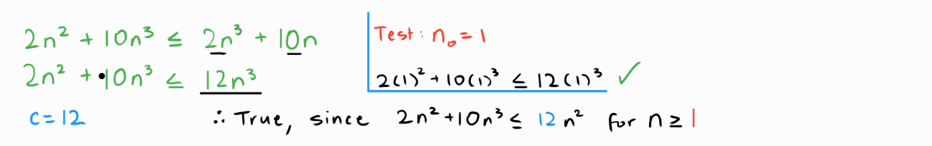

1. *is*

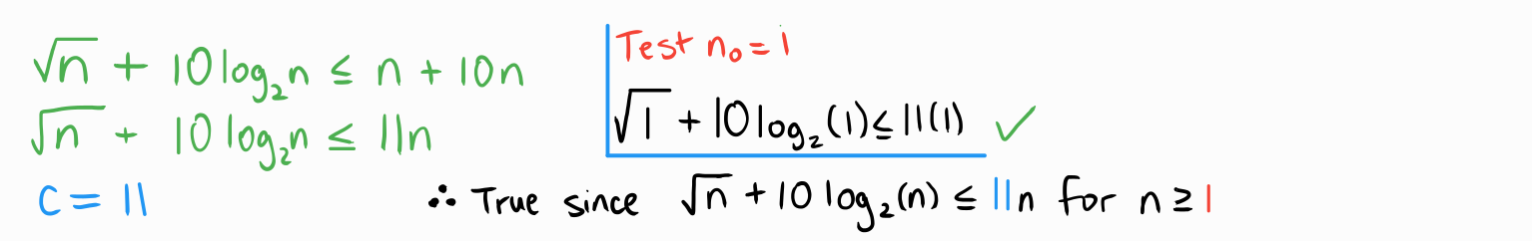

1. *is* Θ(2n)

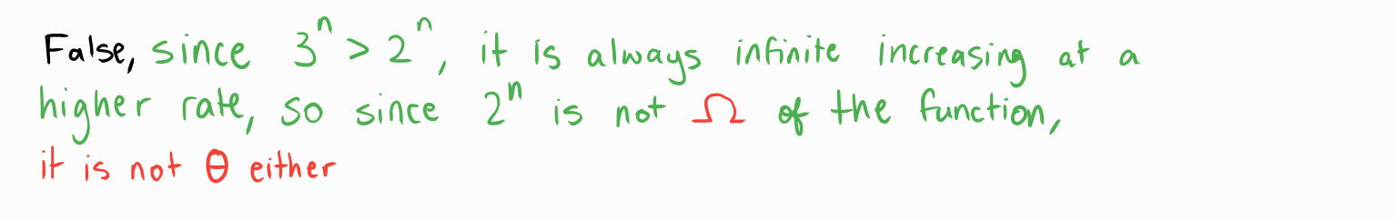

1. *is* )

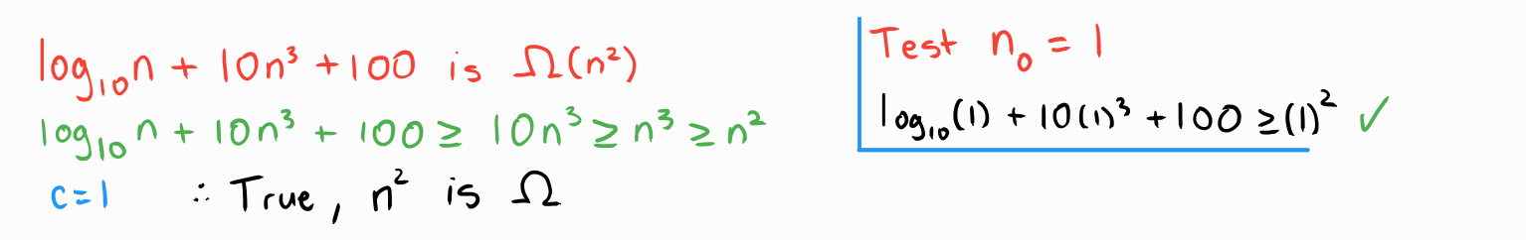

***Question 2. [10 points]***

1. **boolean** isPrime(int n) { // tests if n is a prime number

2. // Input: a positive integer n

3. // Output: return true if n is a prime number, false otherwise

4. **for** (**int** x = 2; x*x <= n; x++) {

5. **if** (n % x == 0) { // found that x divides n

6. **return false**;

7. **}**

8. }

9. return **true**; // found no divisor of n

10. }

***Note:*** *when giving the big-Oh , give the tightest upper bound possible. For example, if you can prove that* f(n) *is* O(n), *and that* f(n) *is* O(n2)*, choose the tighter upper bound, i.e.* f(n) *is* O(n)*.*

1. *(5 pts) Give a big-Oh for* T(n), *the****worst-case****running time of this algorithm for an integer input* n*. Explain how you obtained this worst case.*



1. *(5 pts) Give a big-Oh for* B(n), *the****best-case****running time of this algorithm for an input integer input* n*. Explain the type of inputs (not just one example but an infinite sequence of inputs) that will give this best case.*



***Question 3.* [12 points=10+2]** (a)Write an algorithm to sort a stack of integers such that the smallest elements are on the top. You can only use one (1) additional temporary stack and a constant number of temporary integer variables. You may not copy the elements into any other data structure (such as an array). The stack supports the following operations: *push*, *pop*, *peek* and *isEmpty*. Give pseudocode or Java-like code. (b) Give the worst-case running time in big-Oh notation. You do not need to prove this, but please show your understanding by mentioning which type of instances would give the worst case.

*Note: This question appears often in interviews. First, try to solve it without any hint; do not give up until you think about the question for several days. If after this you can't solve the problem, check the progressive hints on the last page of this assignment. You can also consult a TA or the prof during office hours, who will give you hints, without solving it for you. Asking genAI to solve the problem defeats the purpose of the assignment, and it is against course policies and prevents you from practicing for tests.*

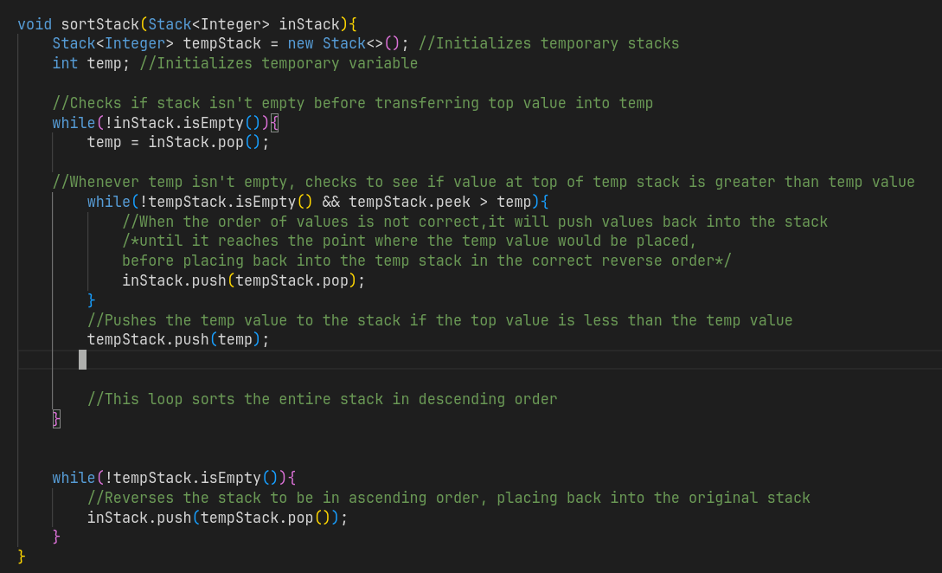

The worst case running time in Big-O will be . Assuming the stack isn’t empty or less than two values, the worst case running time of the first while loop in . Other that same assumption, the second while loop inside the first is also . The Big-O of the nested loops is . The third while is also , but it’s Big-O is smaller than that of the nested loop.

***Question 4.* [12 points = 10+2]** You need to provide operations for simulating a store with two cashiers (each able to serve one customer at a time) and a single (first-come first-serve) lineup of customers.

a)  Provide pseudocode for the following operations:

* Serve(int i): Send first customer in line to cashier i (i∈{1,2}), if line is not empty.
* InterruptService(int i): Send customer currently at cashier i back to the be- ginning of the line.
* Newcustomer(Customer p): A new customer arrives at the end of the cashier lineup.
* GiveUp(int n): the last n customers in line get tired of waiting and abandon the lineup.

Use the most suitable abstract data type (ADT) seen in class as the basis to design the operations above. Your operations must simply call operations on the chosen ADT, without specifying their implementation. Simplicity counts.

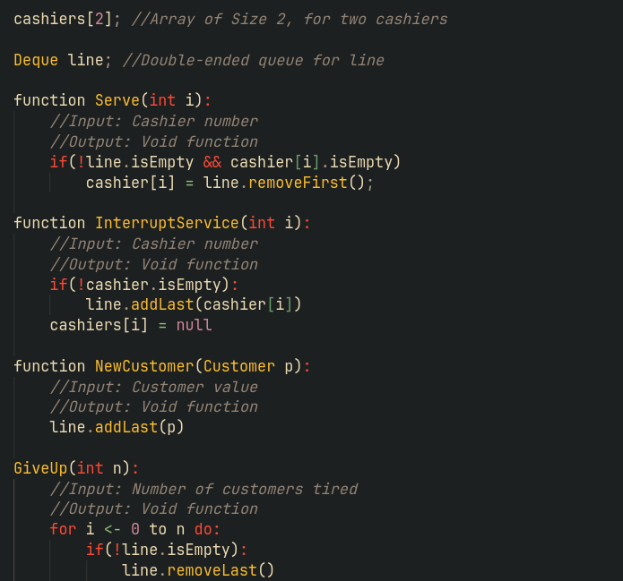

b)  Perform the following operations and show the output, assuming PrintLineup() prints the customers in the lineup from beginning to the end.

Newcustomer(A);

Newcustomer(B);

Newcustomer(C);

PrintLineup();

Serve(2);

Serve(1);

Serve(1);

Newcustomer(D);

Newcustomer(E);

PrintLineup();

InterruptService(2);

InterruptService(1);

PrintLineup();

Newcustomer(F);

GiveUp(2);

PrintLineup();

============

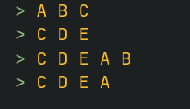

**HINTS for question 3:**

**Hint 1:**

One way to sort the array is to iterate through the array and insert each element into a new array in sorted order. Can you do this using an auxiliary stack?

**Hint 2:**

Imagine your secondary stack is sorted. Can you insert elements into the secondary stack in sorted order using just the primary stack plus a temporary variable that holds 1 element?

**Hint 3: Next page (don't go there so soon!!!)**

**Final hint for Question 3**

Your original stack is S1 and your final stack is S1. At every step, keep S2 sorted with the largest element on top and insert the top element of stack S1 into stack S2, using S1 as auxiliary memory. When S2 contains all elements sorted with the largest element on top, move the elements of stack S2 back to stack S1.

**Example:**

input: intermediate iteration: final iteration: output:

S1 S1 S2 S1 S2 S1

(top)

8 12 1

1 10 3

12 8 5

3 12 7 7

5 5 8 5 8

10 10 3 3 10

7 7 1 1 12

(bottom) (bottom) (bottom) (bottom) (bottom) (bottom)

Note: this question appeared in a previous final exam, with the above hint given.